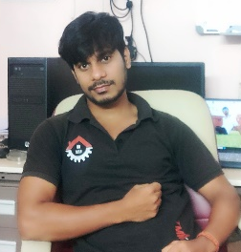
Jiten Kumar Deuri (Assistant Professor in Physics)
I am currently working as Assistant Professor in the Department of Physics. I completed my BSc (Physics) degree in Banki College (Autonomous), Cuttack. I also successfully completed my MSc (Physics) degree in Ravenshaw University, Cuttack. Now I am continuing my Ph.D at CSIR-Institute of Minerals and Materials Technology (formerly RRL), Bhubaneswar as CSIR-UGC NET(SRF). My research interest is based on developing transparent conducting material for various optoelectronics application (particularly in the form of thin films and nanopowders) of metal oxides like ZnO, AZO, GZO etc. and probing their properties for various applications like smart windows, OLED, LCD , Solar cell & also flexible electronic devices. I have 1 research papers & 1 review paper in SCI journals to his credit till date.
Publications
- Jiten Kumar Deuri, Sahu P and Manju U 2023 In Situ Pressure Controlled Growth of ZnO Nanoparticles: Tailoring Sizes, Defects, and Optical Properties Inorg. Chem. 62 7868–76
- Jiten Kumar Deuri, Sahu P, Kalita D, and Manju U 2022 Plasmonic nanostructure integrated two-dimensional materials for optoelectronic devices J. Phys. D. Appl. Phys. 55

